
Greenwood College
Pathway 2 –Year 8-2018
Investigation 1 –Take home section

NAME: _____________________ MARK: _____/____ = _______%

Smooth fractions – Take home section- PART 1
➜ Focus: To calculate fractional quantities for the ingredients in smoothie recipes
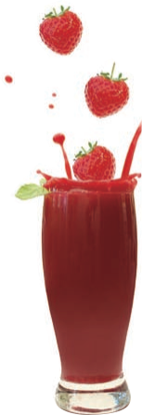
You will need
• Calculator
What to do
Recipe: Strawberry smoothie

Serves 2 people

• 2 bananas
• 2¾ cups of milk
• 3½ scoops vanilla ice-cream
• 5 strawberries
Paris has invited three friends over for a swim and wishes to make strawberry smoothies for them to have by the pool. She finds the following recipe.

- Calculate the amount of each ingredient she will require to make
smoothies for herself and all the friends she has invited.

X 2
_____4 bananas 5 ½ cups milk 7 icecream 10 strawberry
_______________________________________________________________

- Two more friends decide to drop in just as Paris is about to make the smoothies. Find the amount of each ingredient she will need to make smoothies for everyone at the pool.
X 3
_____6 bananas 8 1/4 cups milk 10 1/2 icecream 15 strawberry
_______________________________________________________________
- Paris’ parents then ask if they could have a smoothie also. Calculate the amount of each ingredient she will now require to make smoothies for her 2 parents.
X 1 or x4
2 bananas 2 3/4 cups milk 3 1/2 icecream 5 strawberry
_______________________________________________________________

- To make enough smoothies for her, her 2 parents and all her friends, Paris needs to find the right quantities to make 8 smoothies. Using the information above, find two different ways that she can calculate the quantities needed to make 8 smoothies.
Add them up or multiply them - pay any other reasonable answers
5. Calculate the quantities needed using both the methods you found in question 4.
Are the results what you expected? Explain.

x4
8 bananas 1 3/8 cups milk 1 3/4 icecream 2 1/2 strawberry
_______________________________________________________________
6. Paris spills one smoothie and needs to make a replacement so that she does not miss out.
How much of each ingredient does she require to make one smoothie?

______________________________________________________________________________________________________________________________________________________________________________________________________________________________

Fractions on the farm – Take home section-Part 2
➜ Focus: To explore the four operations on fractions within the real-life context of
picking fruit.
- What to do
Jenny and James have decided to work on a berry farm to pay for some of their expenses as they travel around Australia. The berry farm grows strawberries, raspberries, blueberries and blackberries. In their first hour of picking:
James picked 3¾ buckets of strawberries and Jenny picked 2 $\frac{2}{3}$ buckets.
1. How many buckets did they pick altogether? ________6.4__________
2. Who picked the most and by how much? ____James by 1.08_____________

When collected, the strawberries are placed in 15-kg boxes and then packed into
½kg (500 g), ¾ kg (750 g) or 1¼ kg (1250 g) punnets.

3. How many of the following sized punnets can be packed from the 15 kg box of strawberries?
a) ½ kg _____30_______ b) ¾ kg______20_________ c) 1¼ kg ______12_________

- Jenny and James have been told that one of the 15 kg boxes needs to be divided into two different sized punnets. They need to pack 9 kg of strawberries into½ kg punnets and the remainder of the box into ¾ kg punnets. How many of the following sized punnets can be packed?

- ½ kg = ________18___________ punnets b) ¾ kg ________8________punnets


Greenwood College
Pathway 2 –Year 8-2018
Investigation 1 – In class

NAME: _____________________ MARK: ____/30 = _______%

CALCULATORS ALLOWED: Mobile phones are to be placed in bags at the front of the classroom.
Smooth fractions – Validation in class- Part 1
Paris’ brother, Michael, and his friend, Kevin, join Nikki, Jenna and Paris at Nikki’s house. Everyone wants a ‘Power Smoothie’. The ingredients Paris needs for 1 serve are listed below.

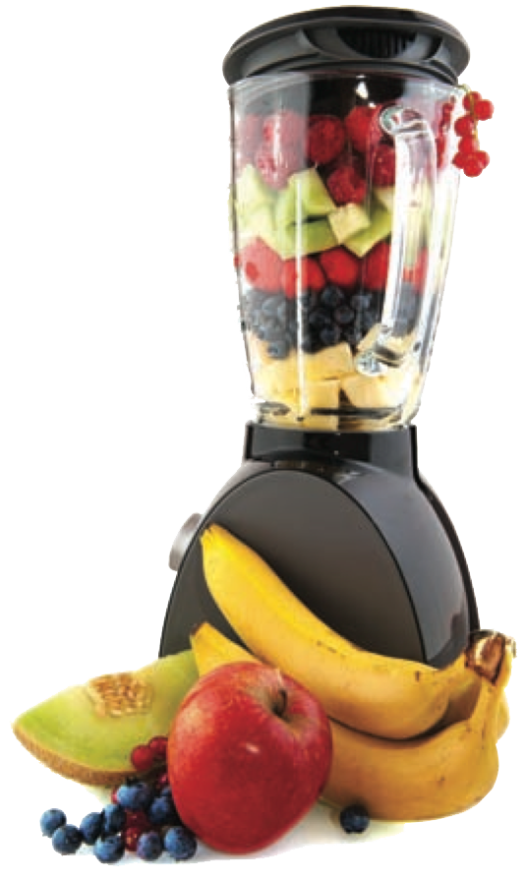

Calculate the amount of each ingredient required to make two Power Smoothies for Michael and Kevin. Include units in all your answers. (7 marks)
Recipe: Power smoothie

Serves 1 person

- 1½ bananas
- 1¾ tablespoons skim milk powder
- 1¼ cups milk

- $\frac{2}{3}$ tablespoons honey

- $\frac{1}{3}$ cup thick yoghurt

3 bananas - 1 mark for value correct
3.5 or 3 2/4 or 14/4 tbsp skim milk powder - 1 mark for value correct
2.5 or 2 2/4 or 10/4 cups milk - 1 mark for value correct
1 1/3 or 4/3 or 4/3 tbsp honey - 1 mark for value correct
2/3 cup yoghurt - 1 mark for value correct
At least 4 units given correctly – 2 marks

Give 1 mark if only units are correct. Follow through marks available if x wrong
2. Find the amount of each ingredient needed to make Power Smoothies for all the people at Nikki’s house. Include units in all your answers. (8 marks)

5 x - 1 mark
7.5 bananas - 1 mark for value correct
8 3/4 or 35/4 tbsp skim milk powder - 1 mark for value correct
6 1/4 or 25/4 cups milk - 1 mark for value correct
3 and 1/3 or 10/3 tbsp honey - 1 mark for value correct
1 and 2/3 or 5/3 cup yoghurt - 1 mark for value correct
At least 4 units given correctly – 2 marks

Give 1 mark if only units are correct. Follow through marks available if x wrong

Fractions on the farm – part 2 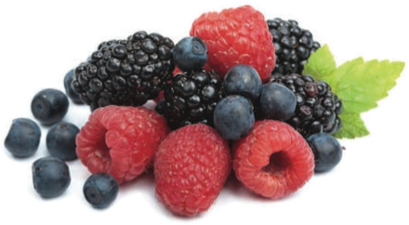

- Raspberries are collected and placed in 18 kg boxes.
They are then packed into ¾ kg punnets or 1¼ kg punnets.
How many of the following sized punnets can be packed from the 18 kg box of
raspberries? (4 marks)
a) ¾ kg ____24_____ b 1¼ kg _____14______

4 a) Which sized punnet results in raspberries being left over in the box?
_______________1 1/4______or b_____________________(2 marks)
- How many kilograms are left? ______0.5kg_________________(2 marks)

The next day, James and Jenny collect blueberries and placed them in a box.
They then packed them into ¾ kg punnets.
When finished, they had 18 punnets and ½ kg of blueberries left in the box.

5. How many kilograms of blueberries did the box hold?
_________13.5 (2 marks) + 0.5 = 14 kg (1)_________________ _(3 marks)
6. Could they pack this amount (answer of Question 5) of blueberries into ½ kg punnets without any left overs? Explain your answer.
_______Yes – goes evenly_____________14/0.5__________________
____________________________________f.t / 0.5__________________(2 marks)
7. Could they pack this amount (answer of Question 5) of blueberries evenly into 1¼ kg punnets? Explain your answer.
No – only 11 whole punnets, remainder doesn’t divide evenly

14 / 1.25 11. ¼ left
2 marks)

THE END

